Objectives

Familiar with Git commands like git init, git status, git add, git commit, git push, and git pull.

In this hands-on lab, you will learn how to
- Setup your machine with Git Configuration
- Integrate notepad++.exe to Git and make it a default editor
- Add a file to source code repository

Prerequisites

- Install Git Bash client in your machine
Notes*:
Please follow the below steps for creating a free account in GitHub.
Don’t use cognizant credentials to login to GitHub.

Estimated time to complete this lab: 30 minutes.

Step 1: Setup your machine with Git Configuration

To create a new repository, signup with GitLab and register your credentials
Login to GitLab and create a “GitDemo” project

- To check if Git client is installed properly: Open Git bash shell and execute

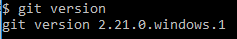
OUTPUT:
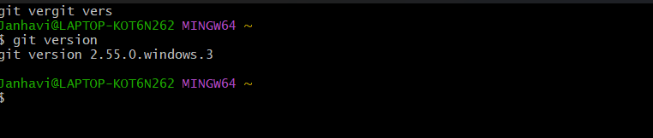

If output shows Git with its version information that indicates, that Git Client installs properly.

- To configure user level configuration of user ID and email ID execute

- To check if the configuration is properly set, execute the following command.

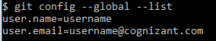
OUTPUT :
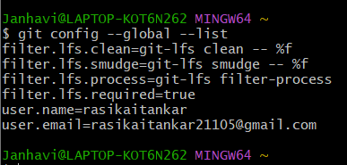
Step 2: Integrate notepad++.exe to Git and make it a default editor

- To check, if notepad++.exe execute from Git bash

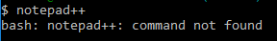
If Git bash could not able to recognize notepad++ command that implies notepad++.exe is note added to the environment path variable.

To add path of notepad++.exe to environment variable, go to control panel -> System -> Advanced System settings. Go to Advanced tab -> Environment variables -> Add path of notepad++.exe to the path user variable by clicking on “Edit”

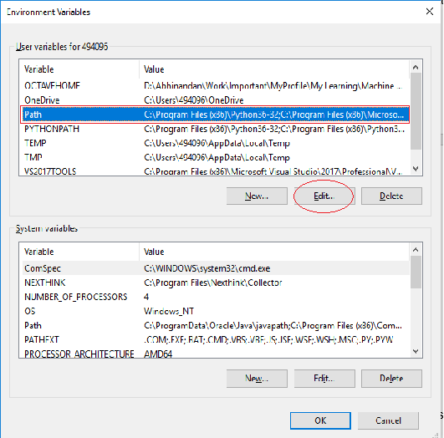

- Exit Git bash shell, open bash shell and execute

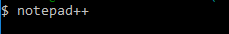

Now, notepad++ will open from Git bash shell

- To create an alias command for notepad++.exe, execute

OUTPUT:
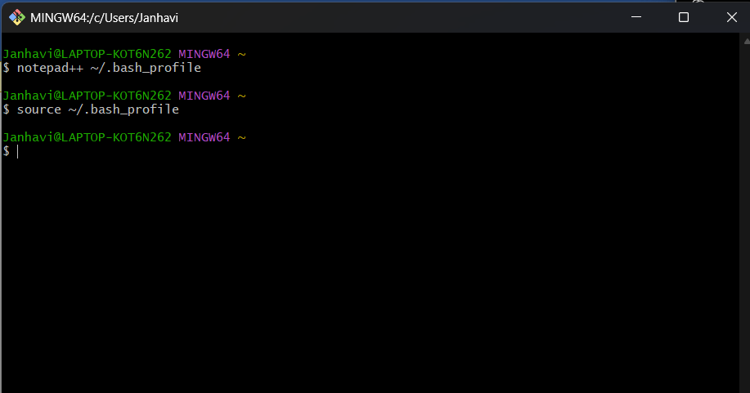

It will open notepad++ from bash shell, and create a user profile by adding the line in notepad++

- To configure the editor, execute the command

- To verify if notepad++ is the default editor, execute the command
Here ‘-e’ option implies editor
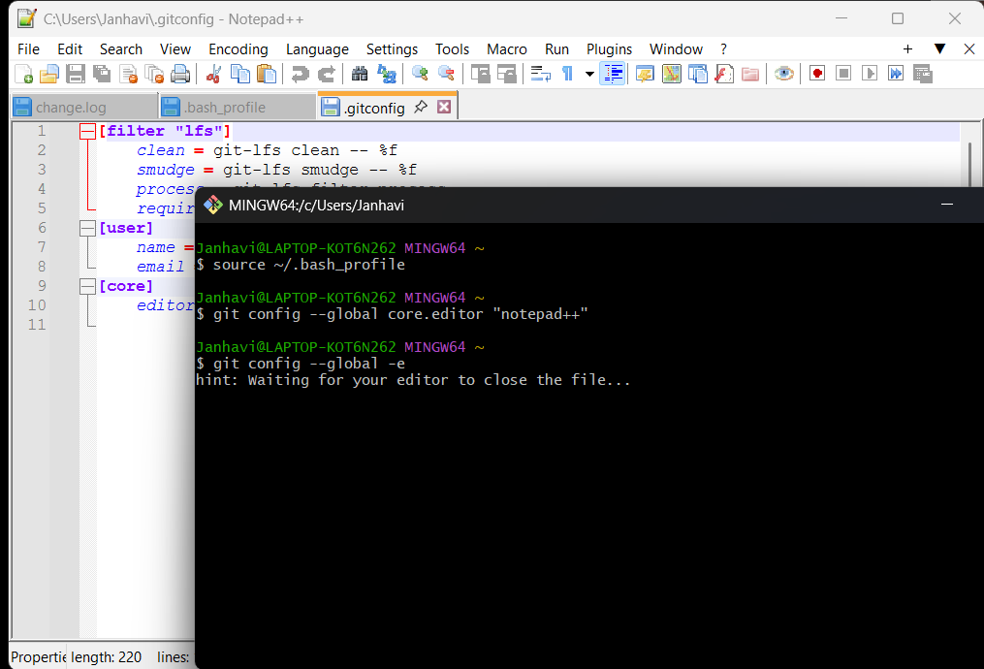
It will show the entire global configuration as shown below,
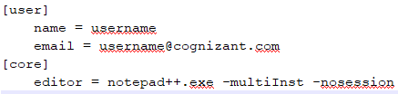

Step 3: Add a file to source code repository

- Open Git bash shell and create a new project “GitDemo” by executing the command

- Git bash initializes the “GitDemo” repository. To verify, execute the command
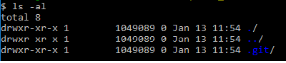
It will display all the hidden files in the Git “working directory”.

- To create a file “welcome.txt” and add content to the file, execute the command

- To verify if the file “welcome.txt” is created, execute
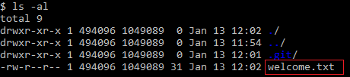

- To verify the content, execute the command

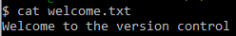

- Check the status by executing
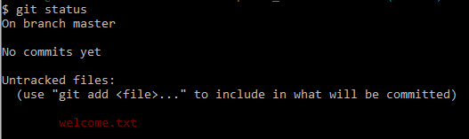

Now the file “welcome.txt” is available in Git “working directory”
OUPUT:
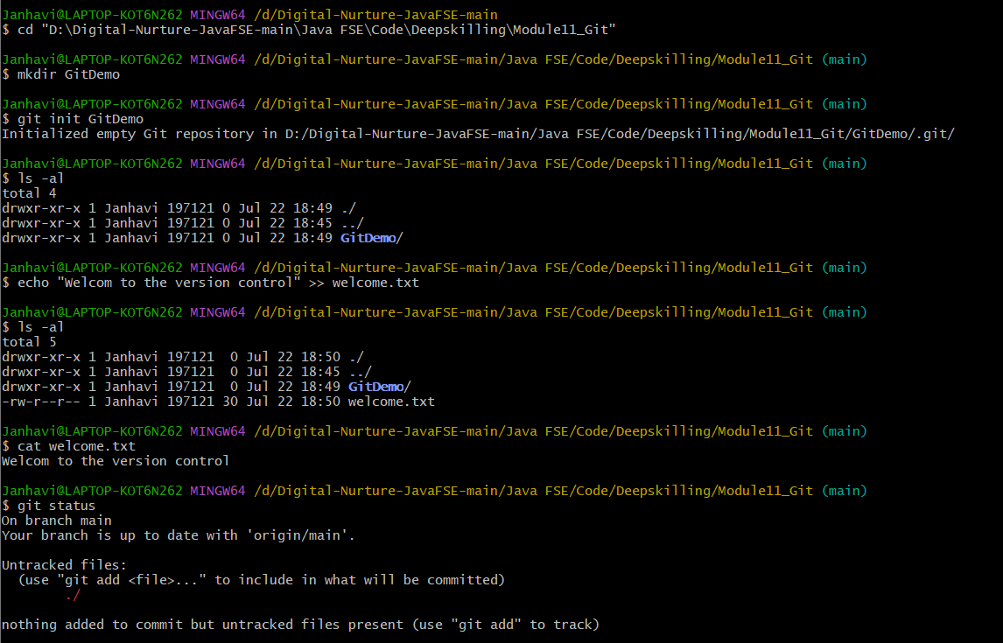

- To make the file to be tracked by Git repository, execute the command

- To add multi line comments, we are opening default editor to comment. Execute the command

Notepad++ editor will open and to add multi-line comment with default editor

- To check if local and “Working Directory” git repository are same, execute git status

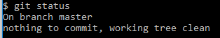

welcome.txt is added to the local repository.
OUTPUT:
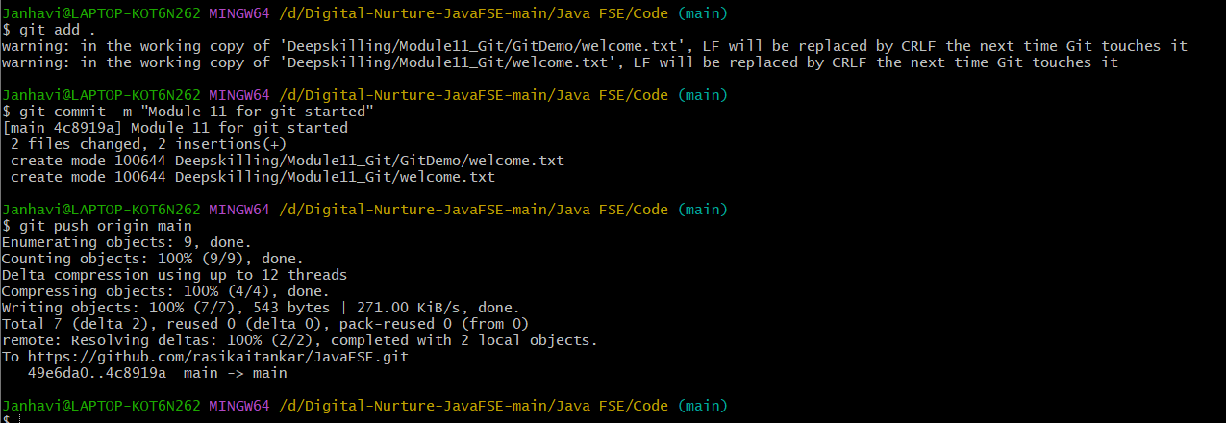
- Signup with GitLab and create a remote repository “GitDemo”
- To pull the remote repository, execute

git pull origin master

- To push the local to remote repository, execute

git push origin master

